Working With Dataset

# Effect Of Existing Heart Disease On Average Of Exercise Angina

|  |  |
| --- | --- |
| Team ID | PNT2022TMID04459 |
| Project Name | Visualizing and Predicting Heart Diseases with an Interactive Dashboard |

## Visualization:

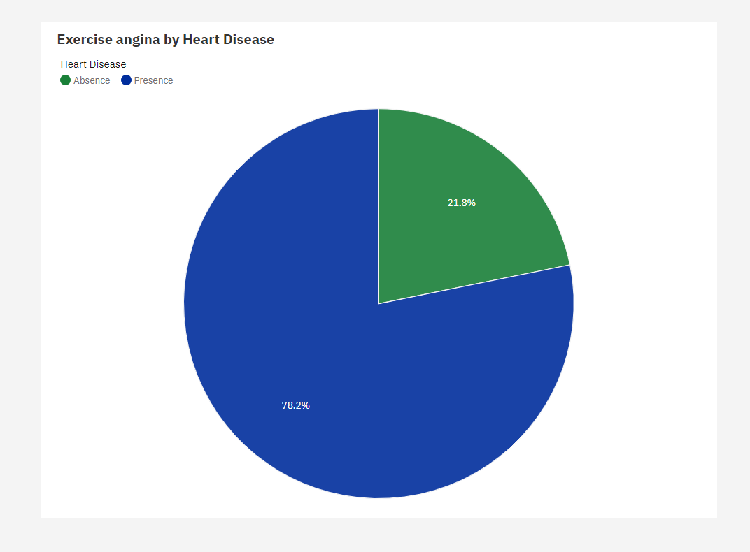

1. The most common value of **Heart Disease** is Absence, occurring 150 times, which is 55.6 % of the total.
2. Over all **heart diseases**, the average of **Exercise angina** is 0.3296.
3. Heart Disease **weakly** affects Exercise angina (17%).
4. The average values of **Exercise angina** range from 0.1533, occurring when **Heart Disease** is Absence, to 0.55, when **Heart Disease** is Presence.